**Hedging Strategy using Variance and Covariance**

**Ankita Dasgupta, J014**

**B.Tech Data Science, Semester III**

**26th August, 2020**

**TELECOMMUNICATIONS SECTOR**

We shall be looking at the five-year, historical data of three companies belonging to the telecommunications sector and shall be making a hedging strategy based on these three companies.

The three companies we are considering for this hedging strategy are

* Tata Teleservices Limited
* Vodafone Idea Limited
* Reliance Communications Limited

**ANALYSIS OF THE TIME SERIES FOR THE PRICES FOR ALL THREE COMPANIES**

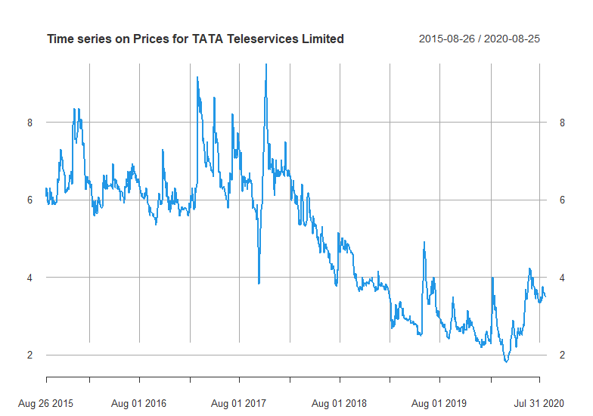

Looking at the time series for the stock prices of Tata Teleservices Limited we can say with confidence that there was a drastic drop in stock prices after the month of February of 2018. Although there was a period when the prices increased after 2019, the were still unable to make the kind of profits they made from the 26th of August 2015 to the 1st of August 2017.

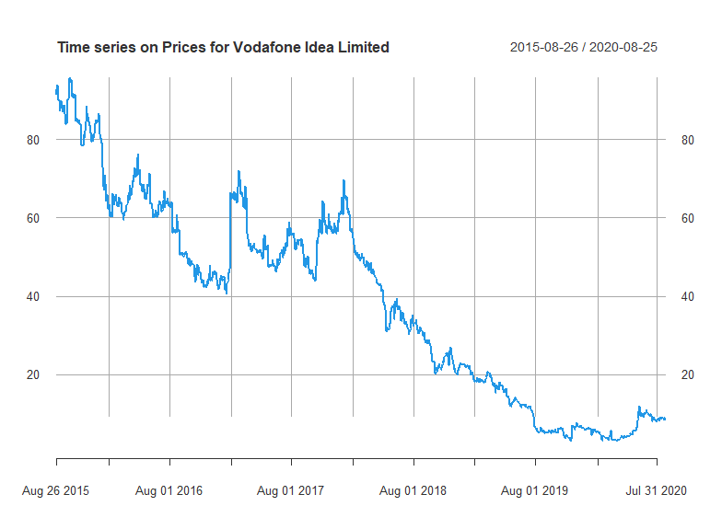

Looking at the fall in prices for the stocks of Vodafone Idea Limited we can see that there were a continuous decrease in their prices after the February of 2017. Looking at the prices after that time period we can say that they were unable to recover their loses either.

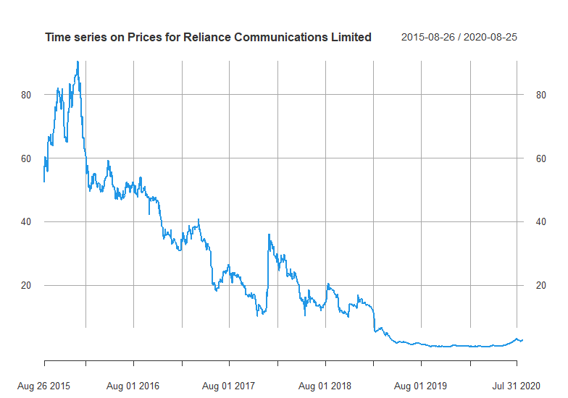

Looking at the fall in prices for the stocks of Reliance Communications Limited we can see that there has been a gradual decrease in the prices after February 2015. It is clear that they were not able to make any significant profits after that. Although they were able to make a little profit between 2017 and 2018, they were not as good as the profits during the period between 2015 to 2017.

The time series for all three companies shows us that all three companies belonging to the telecommunication sector all started incurring losses after 2017 and all three of them were unable to recover. Only TATA Telecommunications limited managed to make some kind of profit later, but they were unable to get the profits they got during 2015 to 2017.

**ANALYZING THE RETURNS OF ALL THREE COMPANIES**

**Descriptive Statistics**

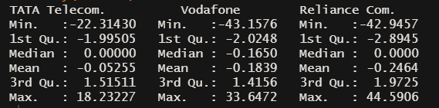

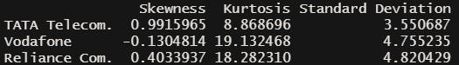

Looking at the Standard Deviation, Median and Mean we can say that there may be multiple outliers in the returns for all three companies.

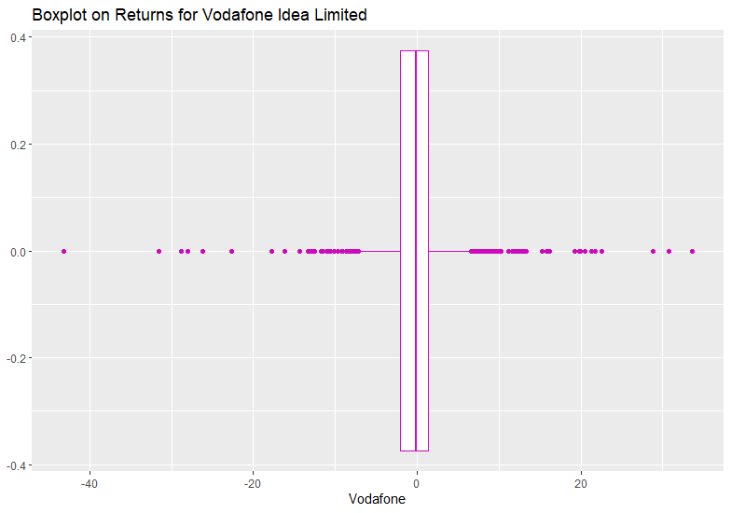

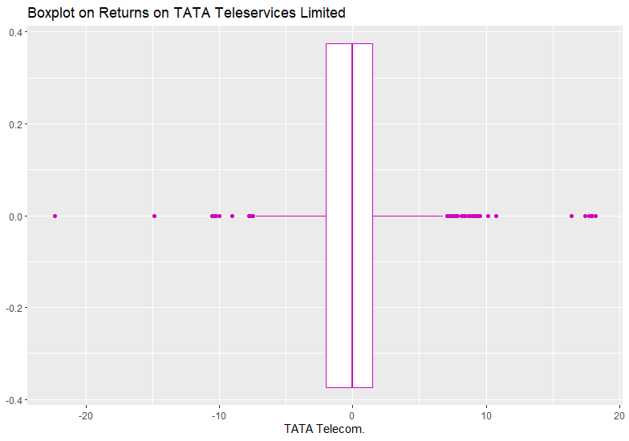

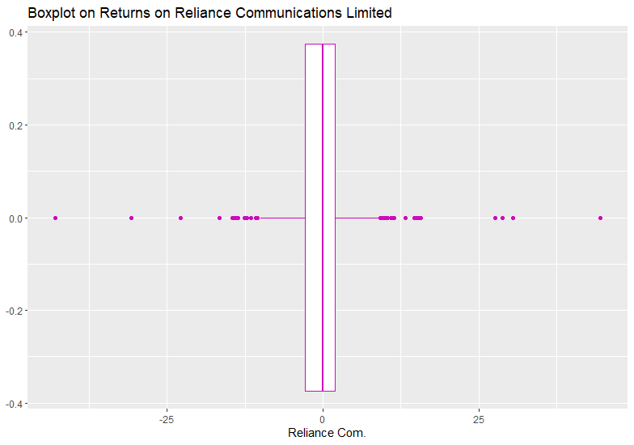

**OBSERVATIONS:**

* The Boxplot along with the for all three Telecommunications Companies show us there are a large number of outliers.
* The high value for standard deviation also tells us that the stocks are highly volatile.
* This may mean they may have abnormal returns.

This can further be verified with the help of histograms.

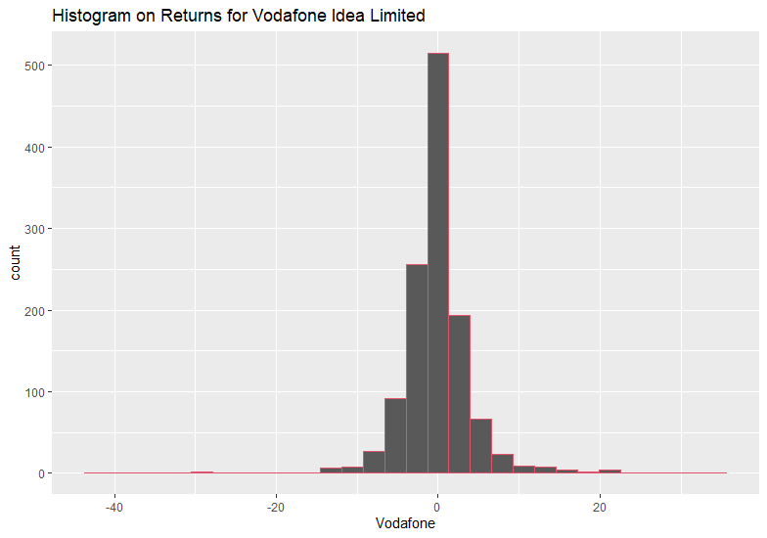

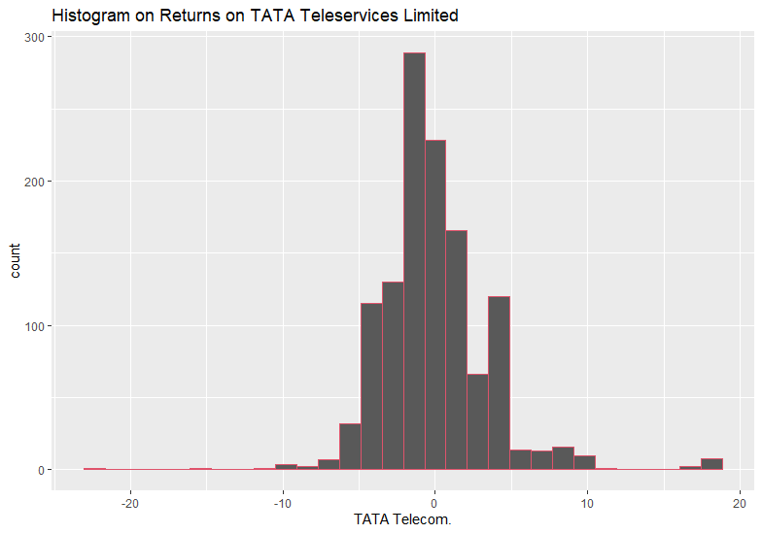

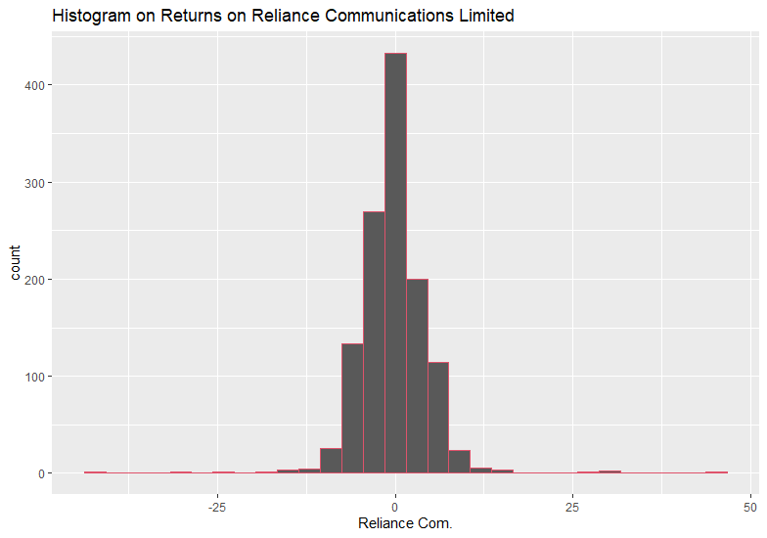

After looking at the histogram along with the skewness and kurtosis we can concur that,

* All three histograms are leptokurtic (Kurtosis > 3)
* The histogram for Vodafone Idea Limited is skewed left, i.e. it has a few high positive returns but mostly gives negative returns (Skewness < 0)
* The histograms for Tata Teleservices Limited and Reliance Communications Limited are skewed right, i.e. it has a few high negative returns but mostly gives low positive returns (Skewness > 0)
* Therefore, among all three companies investing in Vodafone Idea Limited will be comparatively risky

**HEDGING**

Correlation is said to be the interdependence of two variable quantities.

To make a good hedging strategy we need to check if all three companies are correlated, for this we have the table of correlation and the scatterplots for the combinations of each company.

|  |  |  |  |
| --- | --- | --- | --- |
|  | ***TATA Telecom.*** | ***Vodafone*** | ***Reliance Com.*** |
| **TATA Telecom.** | 1 |  |  |
| **Vodafone** | 0.898998485 | 1 |  |
| **Reliance Com.** | 0.760764174 | 0.90149866 | 1 |

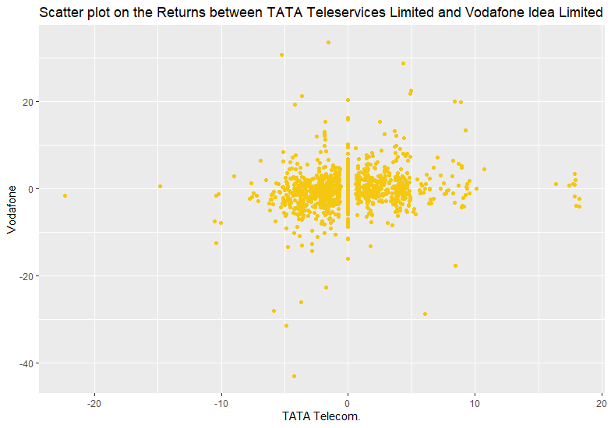

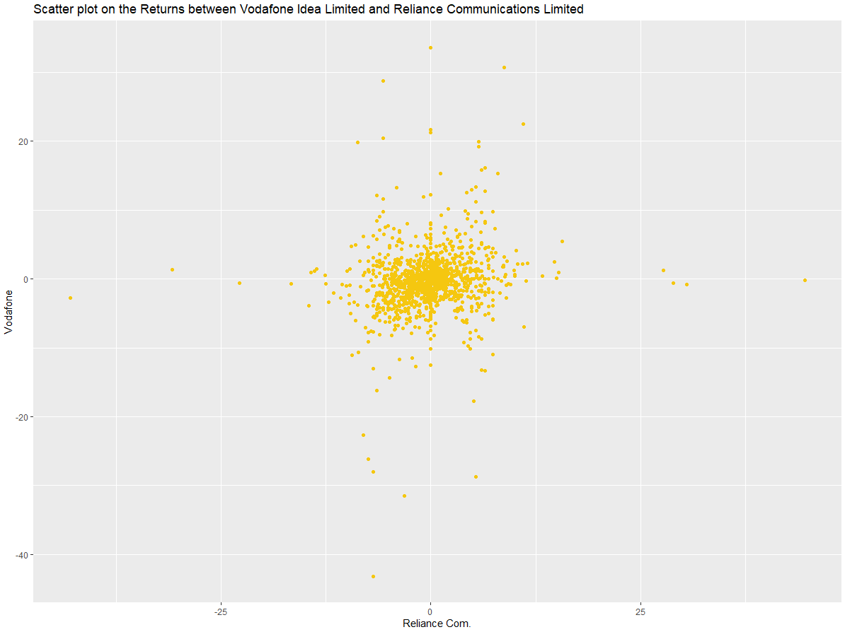

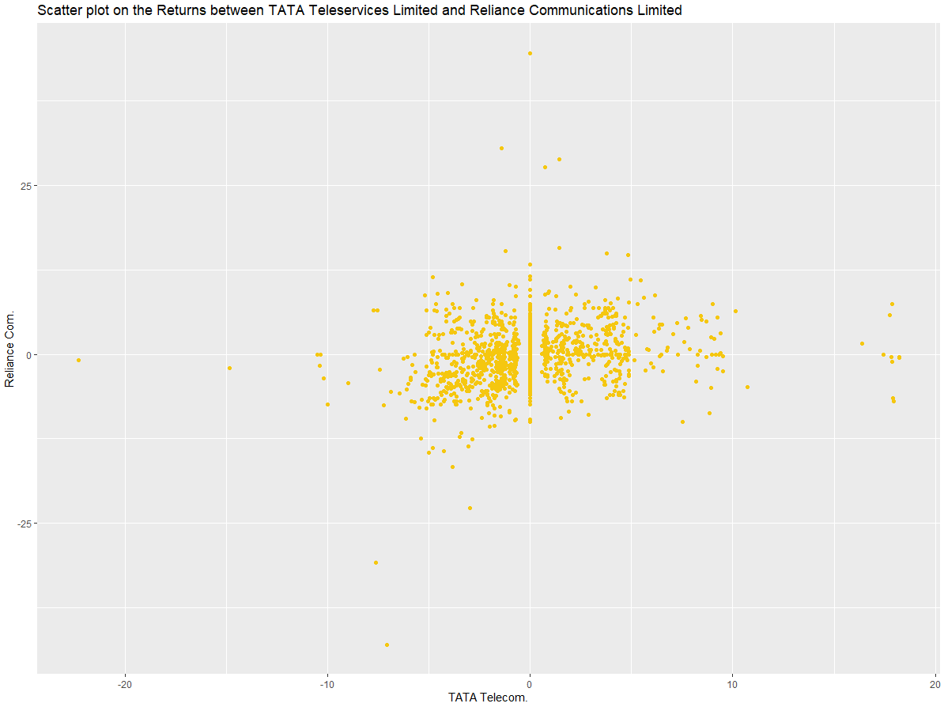

As all three telecommunication companies are highly correlated, we can make hedging strategy after the individual analysis of each company.

**FINAL HEDGING STRATEGY**

|  |  |  |
| --- | --- | --- |
| **HEDGE RATIO** |  |  |
| **TATA Telecom.** | **Vodafone** | **Reliance Com.** |
| 13.19469671 | 1 | 0 |
| 0 | 1 | 1.001040027 |
| 13.19469671 | 2 | 1.001040027 |
| 6.597348357 | 1 | 0.500520013 |
| **65** | **10** | **5** |
| **SELL** | **BUY** | **SELL** |

The best and safest hedging strategy will include,

* Selling sixty-five stocks of Tata Teleservices Limited
* Buying ten stocks Vodafone Idea Limited
* Selling five stocks of Reliance Communications Limited

In alternation.

The line chart shows the fly values of the past five years once we implement the hedging strategy.

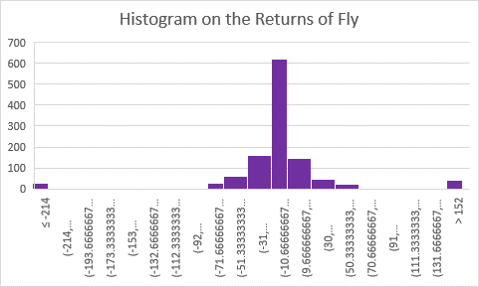

As the histogram is less skewed, we can say that our hedge ratio is valid.

**Source Code:**

library(quantmod)

library(tidyverse)

library(moments)

p1=getSymbols("TTML.NS", source= "yahoo", auto.assign= FALSE, from= "2015-08-26", to= "2020-08-26")[,4]

r1=na.omit(diff(log(p1)))*100

View(r1)

summary(r1)

p2=getSymbols("IDEA.NS", source= "yahoo", auto.assign= FALSE, from= "2015-08-26", to= "2020-08-26")[,4]

r2=na.omit(diff(log(p2)))*100

View(r2)

summary(r2)

p3=getSymbols("RCOM.NS", source= "yahoo", auto.assign= FALSE, from= "2015-08-26", to= "2020-08-26")[,4]

r3=na.omit(diff(log(p3)))*100

View(r3)

summary(r3)

p1=na.omit(p1)

p3=na.omit(p3)

p2=na.omit(p2)

prices=data.frame(p1,p2,p3)

View(prices)

summary(prices)

returns=data.frame(r1,r2,r3)

View(returns)

cor(returns)

cor(prices)

colnames(prices)=c("TATA Telecom.","Vodafone","Reliance Com.")

colnames(returns)=c("TATA Telecom.","Vodafone","Reliance Com.")

plot(p1, main="Time series on Prices for TATA Teleservices Limited ", lwd=2, col=4)

plot(p2, main="Time series on Prices for Vodafone Idea Limited", lwd=2, col=4)

plot(p3, main="Time series on Prices for Reliance Communications Limited ", lwd=2, col=4)

summary(returns)

std=c(sd(returns$`TATA Telecom.`),sd(returns$Vodafone),sd(returns$`Reliance Com.`))

sk=data.frame(skewness(returns), kurtosis(returns), std)

colnames(sk)=c("Skewness","Kurtosis","Standard Deviation")

sk

View(sk)

ggplot(data = returns)+

geom_boxplot(mapping = aes(x=`Vodafone`), col=6)+

labs(title = "Boxplot on Returns for Vodafone Idea Limited")

ggplot(data = returns)+

geom_boxplot(mapping = aes(x=`TATA Telecom.`), col=6)+

labs(title = "Boxplot on Returns on TATA Teleservices Limited")

ggplot(data = returns)+

geom_boxplot(mapping = aes(x=`Reliance Com.`), col=6)+

labs(title = "Boxplot on Returns on Reliance Communications Limited")

ggplot(data = returns)+

geom_histogram(mapping = aes(x=`Vodafone`), col=2)+

labs(title = "Histogram on Returns for Vodafone Idea Limited")

ggplot(data = returns)+

geom_histogram(mapping = aes(x=`TATA Telecom.`), col=2)+

labs(title = "Histogram on Returns on TATA Teleservices Limited")

ggplot(data = returns)+

geom_histogram(mapping = aes(x=`Reliance Com.`), col=2)+

labs(title = "Histogram on Returns on Reliance Communications Limited")

ggplot(data = returns)+

geom_point(mapping = aes(x=`TATA Telecom.`, y=`Vodafone`), col=7)+

labs(title = "Scatter plot on the Returns between TATA Teleservices Limited and Vodafone Idea Limited")

ggplot(data = returns)+

geom_point(mapping = aes(x=`Reliance Com.`, y=`Vodafone`), col=7)+

labs(title = "Scatter plot on the Returns between Vodafone Idea Limited and Reliance Communications Limited")

ggplot(data = returns)+

geom_point(mapping = aes(x=`TATA Telecom.`, y=`Reliance Com.`), col=7)+

labs(title = "Scatter plot on the Returns between TATA Teleservices Limited and Reliance Communications Limited")